**Project Design Phase-II**

**Technology Stack (Architecture & Stack)**

|  |  |
| --- | --- |
| Date | 23 October 2023 |
| Team ID |  |
| Project Name | A Reliable Energy Consumption Analysis System For Energy-Efficient Appliances |
| Maximum Marks | 4 Marks |

**Technical Architecture:**

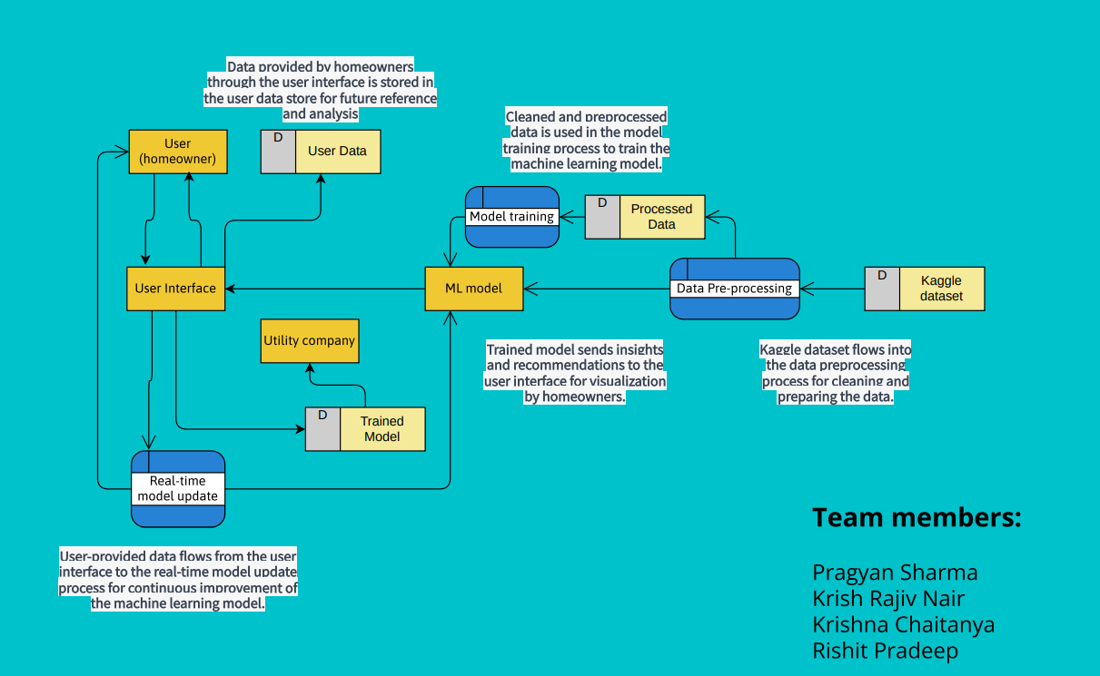

Guidelines:

1. Include all the processes (As an application logic / Technology Block)
2. Provide infrastructural demarcation (Local / Cloud)
3. Indicate external interfaces (third party API’s etc.)
4. Indicate Data Storage components / services
5. Indicate interface to machine learning models (if applicable)

**Table-1 : Components & Technologies:**

|  |  |  |  |
| --- | --- | --- | --- |
| **S.No** | **Component** | **Description** | **Technology** |
| 1. | Data Manipulation and Analysis | Used for data manipulation, cleaning, and analysis. It provides data structures like Data Frames, which are used extensively in the code. | Pandas |
| 2. | Numerical and Scientific Computing | Fundamental package for scientific computing with Python. It provides support for large, multi-dimensional arrays and matrices, along with mathematical functions. | NumPy |
| 3. | Machine Learning | A popular machine learning library in Python that provides simple and efficient tools for data mining and data analysis. It includes various tools for classification, regression, clustering, and more. | scikit-learn (sklearn) |
| 4. | Machine Learning | An ensemble learning method for regression tasks, part of scikit-learn. | Random Forest Regressor |
| 5. | Data Visualization | A plotting library for creating static, interactive, and animated visualizations in Python. | Matplotlib |
| 6. | Data Visualization | A statistical data visualization library based on Matplotlib. It provides a high-level interface for drawing attractive and informative statistical graphics. | Seaborn |
| 7. | Others | Python module for working with dates and times, used for converting date and time columns. | Datetime |
| 8. | Others | The code involves reading and saving data in CSV format. | CSV |
| 9. | Component UI | Each component encapsulates a piece of the user interface, its behaviour, and its styling. code modularity, reusability, and maintainability | React |
| 10. | Interactivity | Triggering and controlling animations .Executing code after a specified delay or at regular intervals. Fetching data from a server asynchronously without refreshing the entire page. Modifying the styles of elements Capturing keyboard inputs. Handling mouse-related events such as hover, enter, leave, etc. Responding to user clicks on elements like buttons or links. | Java Script |
| 11. | Styling, and visual aesthetic( font spacing etc) | setting the background, adjusting text styles, and defining the layout. | CSS |

**Table-2: Application Characteristics:**

|  |  |  |  |
| --- | --- | --- | --- |
| **S.No** | **Characteristics** | **Description** | **Technology** |
| 1. | Open-Source Frameworks | Leveraging open-source deep learning frameworks for building, training, and deploying the machine learning model. | Scikit-learn for pre-processing and data analysis. |
| 2. | Security Implementations | Incorporating security measures to protect data, user interactions, and system components, ensuring data privacy and system integrity. | Secure communication protocols (HTTPS). Authentication and authorization mechanisms. Data encryption at rest and in transit. |
| 3. | Scalable Architecture | Designing the system to handle varying workloads and adapt to changing demands by employing a scalable and flexible architecture. | Serverless computing for event-driven scalability. |
| 4. | Availability | Ensuring high availability by minimizing downtime, fault tolerance, and redundancy to guarantee that the system is always available. | Multi-region deployment for redundancy. |